Reference No: |  | Date
Requested by  Name : Elyas Hinri  Position : Assistant Manager, PF-Product Development, CCG |  | Recommended by  Name : Ajith Jayaram  Position : Head of CCG
SUBJECT | Aeon-iCash (PF) Extension Tenure
DEPARTMENT | Consumer Credit Group (CCG)

Purpose
To seek management approval to launch the PF tenure up to 8 years (96 months).

Objective
- To improve PF sales.
- To improve ACS market positioning in the PF industry.

Background
- AEON iCASH (PF) was launched back in 2006 targeted at the low income group earner offering finance amount up to RM50,000 and a maximum tenure of 60 months.
- After a tremendous growth since the launch of PF, therefore PFBG is proposing to embark into the next phase by revising on the following product feature;
- Extension of finance tenure: maximum of 60 months (existing) and the revised tenure is up to a maximum of 96 months.
- The conclusion from the analysis can be made was that the longer the tenure offered and taken by customer, the lower the bad debt ratio it would be hence this will justify the introduction of extension of finance tenure up to 96 months will lower down the PF bad debt ratio. Refer to Appendix I
- Based on the graph depicted in Appendix II it has shown an increasing trend on the overall sales and ending nett receivable (ENR) growth for PF since 2010 till year to date which reflects steadily portfolio growth with actual YTD ENR at RM827.47million (as of August 2014).
- FYE 2014, we foresee substantial demand from customers with the extension of loan tenure and the introduction of cash back feature as the market size for personal loan is massive hence enable ACSM to increase and reached out to wider market coverage and provide competitive edge against other market players.
Aeon-iCash Product Features

- Changes in the product feature includes;
- Extension of tenure up to 8 years.
- Existing tenure for Aeon-iCash offered to the market is up to 5 years or 60 months
- With the enhancement of the tenure, the new tenure to be offered to the market will be 6 months, 9 months, 12 months, 15 months, 18 months, 24 months, 30 months, 36 months, 48 months, 60 months, 72 months, 84 months and 96 months.

Below are the summary of the existing product feature against the enhanced product feature.
- Personal Financing Department is with the assumption that with the proposed enhanced product feature and risk analysis (kindly refer page 3), this product feature enhancement is a product variation of existing PF product with no material risk.

Item | Existing | Enhanced
Tenure (months) | 6, 9, 12, 15, 18, 24, 30, 36, 48, 60 | 6, 9, 12, 15, 18, 24, 30, 36, 48, 60, (New Tenure - 72, 84, 96)
Minimum Borrowing | RM1,000 | No change
Maximum Borrowing | RM50,000 | No change
Guarantor | No | No change
Profit Rate | - < RM5k, 1.2%p.mth, 1.5% p.mth.  - >= RM5k, 0.80% mth., 0.84% p.mth. | No change
Late Payment Charges | 1% p.a. against outstanding amount | No change
Processing Fee | 6% for finance amount < RM5k | No Change
Credit Scoring | Based on existing ACSM PF scoring – Stipulated in the ACS policy | No Change
Turnaround time | 3 working days (up to crediting into customer account. | No change

Competitor Analysis
 |  | AEON Credit Services | RHB Bank | Maybank | CIMB Bank | MBSB | Alliance Bank | Bank Islam
1 | Product Name | AEON iCASH | RHB Personal Financing | Maybank Personal Loan | Cash Plus Personal Loan | MBSB Personal Financing-I Private Sector | CashFirst Personal Loan | Personal Financing-i
2 | Applicant Eligibility | - Malaysian citizen aged between 18 and above. | - Malaysian citizen aged between 21 years to 55 years old  - Minimum income of RM18K per annum | - Individual Malaysian citizen aged between 21 years to 60 years old  - Minimum income of RM30,000 per annum | - Individual applicant only  - Aged between 21 years to 60 years upon application  - Minimum income per month RM2,000 (basic + fixed income only) | - Individual Malaysian citizen aged between 21 years to 60 years old  - Minimum income of RM42,000 per annum | - Malaysian and permanent residents working and residing in Malaysia only.  - Malaysians working in Singapore, but residing in Malaysia will be considered.  - Aged between 21 years to 60 years old  - Minimum income of RM24,000 per annum | - Applicant must be 18 years and not exceeding the retirement age at the end of payment period.  - Malaysian citizen.  - Earning a minimum fixed income of RM2, 000 per month.  - Applicant must be a continued employee in any of the following:  - Government Sector.  - Selected Public Listed Companies.  - Subsidiaries of Government or Selected Public Listed Company.  - Other Prominent Private Limited Companies as categorized under package companies listed by Bank Islam
3 | Target Market Segment | - Low income earners – middle range income earners | - Middle range income earners | - Middle range income earners – affluent income earner | - Middle range income earners – affluent income earner | - Government Servant & Government Link Companies employees & Private Sector Employee | - Middle range income earners – affluent income earner | - Middle range income earners – affluent income earner
4 | Loan/ Finance Amount | - Minimum: RM1,000  - Maximum: RM50,000 | - Minimum: RM2,000  - Maximum: RM150,000 | - Minimum: RM5,000  - Maximum: RM100,000 | - Minimum: RM 2,000  - Maximum: RM100,000 | - Minimum: RM 10,000  - Maximum: RM300,000 | - Minimum: RM2,000  - Maximum: RM200,000 | - Minimum: RM2,000  - Maximum: RM200,000
5 | Tenure | - Minimum: 1 year  - Maximum: 8 years (NEW) | - Minimum: 1 year  - Maximum: 7 years | - Minimum: 2 years  - Maximum: 6 years | - Minimum: 1 year  - Maximum: 5 years | - Minimum: 2 years  - Maximum: 10 years | - Minimum: 1 year  - Maximum: 7 years | - Minimum: 1 year  - Maximum: 10 years
6 | Pricing | - RM1,000- RM4,999, 1.2%p.a, 1.5% p.a.  - RM5k-RM50,000, 0.80% p.a., 0.84% p.a. | - Tier1: RM2,000 – RM10,000 @ 13.45% p.a  - Tier2: RM11,000 – RM50,000  @ 11.66% p.a  - Tier3: RM51,000 – RM99,000  @ 9.91% p.a  - Tier4: RM100,000 – RM150,000 @ 8.18% p.a | - Tier 1: RM5,000 – RM20,000 @ 8%p.a  - Tier 2: RM20,001 – RM50,000 @ 7%p.a  - Tier 3: RM50,001 – RM100,000 @ 6.5%p.a  Note: calculation based on fixed rate | - Tier 1: RM2,000 – RM24,000 @ 13.38% p.a  - Tier 2: RM25,000 – RM49,000 @ 9.88% p.a  - Tier 3: RM50,000 – RM100,000 @ 6.88%p.a | - Effective rate BLR + 2.50% | - 10.38% p.a (flat rate basis) | Flat Rate  - 1-3 years : 3.25% p.a. (with Bank Islam Will Writing, BancaTakaful products subscription or Bank Islam Card-i).  - 1-3 years: 3.50% p.a.  - 4-10 years: 4.99% p.a.  BFR Rate  - 1-3 years: BFR - 1.65% p.a.  - 4-10 years: BFR - 0.35% p.a.  Note: Current BFR is 6.60% p.a.
7 | Margin Of Financing | Up to allowable ACS DSR | Up to 5x gross salary | ~ | ~ | ~ | Up to 5x gross salary | ~
8 | Stamp Duty | 0.5% stamp duty based on finance amount | 0.5% stamp duty based on loan amount | NIL | 0.5% stamp duty based on loan amount | 0.5% stamp duty based on loan amount | 0.55% stamp duty based on loan amount | Stamp duties( as per stamp act 1949, Revised 1989).  Wakalah @ agency fee RM500
9 | Insurance/ Takaful coverage | Optional | Compulsory | Compulsory | Compulsory | Compulsory | NIL | Compulsory
10 | Processing Fee | 6% for finanacing amount < RM5k | NIL | NIL | NIL | RM120 | NIL | NIL
11 | Upfront Payment | Nil | NIL | NIL | NIL | NIL | NIL | If payment via Standing Instruction, bank Islam may request 2 months advance payment.
10 | Payment Due Date | 2nd of every month. | The following anniversary month | Within 30 days from date of disbursement of the Facility or successive intervals of one (1) month | 1 month from the date of disbursement | The following anniversary month | 1 month from the date of disbursement | The following anniversary month
11 | Late Payment Charges | After due date – 10th = RM18.  11th – 18th = RM23.  19th onwards = RM40 | 1% per annum of payment in arrears due, calculated on daily basis until such arrears are paid in full | 1% per annum on the amount in arrears, calculated from overdue date till date of full monthly payment | 1% per annum on the amount in arrears, calculated from overdue date till date of full monthly payment | 1% per annum on the amount in arrears, calculated from overdue date till date of full monthly payment | 1% p.a on instalment amount overdue, accruing from the due date up to the date of settlement | 1% p.a on overdue instalment amount overdue, accruing from the due date up to the date of settlement
12 | Lock-in Period | NIL | YES (6 months from disbursement date) | NIL | YES (1 year from disbursement date) | NIL | NIL | NIL
13 | Early Exit Fee | NIL | RM100 or 1% whichever is higher, is charge if prepayment in full is made during the lock-in period of 6 months from the date of the letter of approval is issued. | RM200 or sum equivalents to 3% of the outstanding balance of the loan whichever is higher, only if settled within first half of the tenure. | RM200 for early settlement during the lock-in period. | 5% of remaining amount | A three (3) months’ written notice or three (3) months’ interest in lieu of such notice is required. | Bank grant to customer a (rebate) which is equivalent to the deferred Profit at the point of settlement
14 | Processing Flow and Time | - 3 working days | - 3 working days | - 3 working days | - Within 24 hours (approval + disbursement) | - Up to 5 days. | - Up to 5 working days | - 2 working days.
15 | Latest Receivable Amount | RM 827,000k | RM 7,183,000k | RM 6,283,000k | RM 7,776,000k | RM 23,388,000k | RM1,259,000k | RM 8,516,000

Appendix F: Risk Analysis

Nature of Risk | Increase in risk | Risk Mitigation
Nature of Risk | Increase in risk | Impact to ACSM |  |  | Impact to Customer
Nature of Risk | Yes/No | Monitor | Measure | Control | Meeting needs & affordability
Transactional/ Operational Risk | Operational Readiness  Increase in Risk = No | - To follow the existing end-to-end process flow with minimal enhancement to cater for the additional requirement.  - To use SAFE approach as per guided by Legal & Compliance dept for suspicious transactional activity which consist of;  - Screen for suspicious activity indicator.  - Ask appropriate question.  - Find out the customer’s record.  - Evaluate the above information. | - All User Change Requirement is spelled out clearly to ensure the delivery both at front end and backend are met.  - Level of suspicious activity based on evaluation made from SAFE guideline. | - SIT and UAT will be carried out to ensure operational process is in placed to cater for the necessary changes prior to the actual product launch.  - Raise an Internal Suspicious Transaction Report (ISTR) in the event suspicious transaction is detected to ACS compliance officer for further investigation. | - No Impact to customer
Credit Risk | Non-repayment  Increase In Risk = No  There is no material change to existing risk profile as the credit criteria and score card is following the existing PF credit scoring. | - Full CCRIS and CTOS checks on all applications  - Monitor via tripwire  - To conduct annual product review at least once a year after the implementation. | - All new application submission is to go through the personal financing credit scoring built into the system.  - Total NPL ratio or ever percentage of 90+date past due | - Policy rules constantly reviewed (CPM) to improve asset quality  - Business to review the portfolio whenever NPL reaches 4.0 %. Business to submit review paper to EC or collection ratio reaches 98.5% or RM30milion new sales per month from existing sales whichever comes first. | - No Impact to customer
Market Risk | Interest Rate Risks, Exchange Rate Risks, Liquidity Risks  Increase In Risk = No | - ACS market risks are managed within approved market limits. | - As per company’s prevailing accepted value at risk. | - The liquidity mismatch arising from these products is consolidated and managed within the company’s overall liquidity limits. | - No Impact to customer
Regulatory/ Legal Risk | - FSA and related notices  Increase in Risk = No | - Credit assessments are governed within BNM guidelines in providing unsecured lending. | - ACS is responsible to provide accurate and up-to-date credit information of our borrowers to BNM Credit Bureau.  - ACS shall comply with and provide all relevant information to facilitate any audit trail as requested by the Regulators. | - FSA is to be strictly adhered to.  - Staff are trained and continuously reminded on the importance of granting credit facilities to staff and directors under the new Guidelines on “Credit Transactions and Exposures with Connected Parties”. | - No Impact to customer
Regulatory/ Legal Risk | - Guidelines on BLR, Lending and Deposit  Increase in Risk = No | - The sales staff must clearly explain and disclose to borrowers the pricing method or calculation used for this product.  - All Rates and Charges are to be printed on the monthly statements. | - All existing and new guidelines imposed by BNM are to be adhered to and incorporated into our product requirement.  - Extensiveness of the terms and conditions governing the product. | - Fees and charges are disclosed and explained to Customer prior to loan application.  - All fees and charges are printed prominently in all of our marketing collaterals.  - All application forms and Terms and Conditions are vetted and endorsed by Group Legal.  - Terms and Conditions together with Product Disclosure Sheet (PDS) will be provided to customer and a copy of Terms and Conditions as well as Product Disclosure Sheet (PDS) will be submitted to BNM together with the proposal paper for approval prior to product launch. | - Customer will benefit from the explanation of the sales staff together with the Product Disclosure Sheet (PDS) given to the customer for easier understanding and future reference on the product offerings and the Terms and Conditions.
IT Risk | Increase in risk = No | - Monitor IT project performance from system development to SIT to UAT.  - Ensure test scripts are comprehensive to cover all possible (negative and positive tests).  - To perform system review post implementation. | - User to ensure additional User Requirement is catered for and all other existing system ruling remains unchanged.  - System development against agreed project timeline.  - At least 1 month of User Acceptance Tests (UAT).  - Post review testing results to monitor any inconsistencies of IT hiccups. | - Thorough UAT (end to end) will be done prior to launching the system enhancement | - No Impact to customer
Money Laundering/Terrorism Risk | Anti Money Laundering and Counter Financing of Terrorism (AML/CFT)  Increase In Risk = No | - To adhere to AML/CFT program and AML system reference guide.  - ACS customer black list checking.  - AML alerts checking. | - Automated screening of customer against the sanction and internal list. | - Training and awareness programmes should be conducted regularly and supplemented with refresher courses for employees, with special emphasis for those employees who are exposed to higher risk of potential money laundering and financing of terrorism activities.  - System is enabled to perform negative list checking where every New-To- ACS customers go through the screening of AML during assessment queue. | - N/A
Reputational Risk | Increase in risk = No | - Breaches and incidents are reported and remedial actions must be reviewed and agreed by Business Heads.  - Customer complaints on non-disclosure of product features. | - Staff required to have read and understood the company’s policies.  - All complaint will be investigated for remedial action. | - All new staff is required to attend product training and induction program.  - Training and awareness programmes should be conducted regularly and supplemented with refresher courses for employees.  - To contact customer for investigation and escalate the issue to CSI. The above exercise shall be as per standard operating procedure. | - N/A
Liquidity/ Funding Risk | N/A
Accounting and Financial Reporting | N/A
Public Relations Risk | N/A
Human Resource Risk | N/A

Appendix G: Operating Process and Procedures/ Workflows
- There is no change to the existing end to end financing application process flow. Existing flow is depicted below;
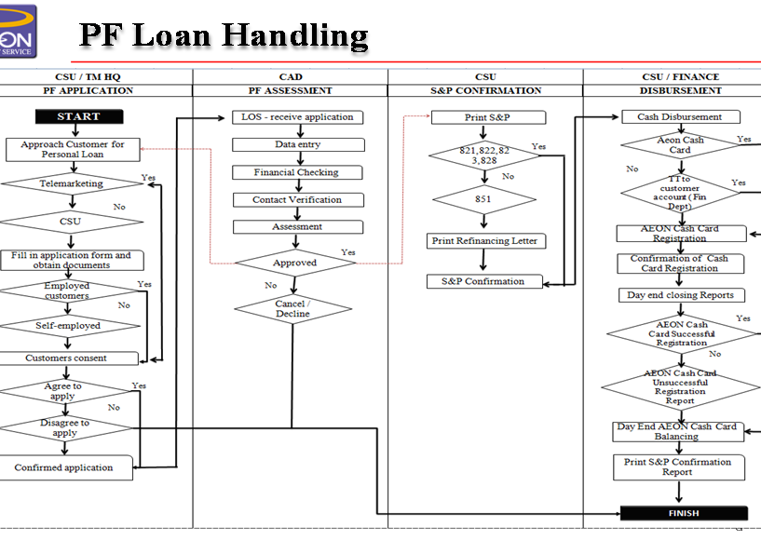
Cost & Benefit Analysis

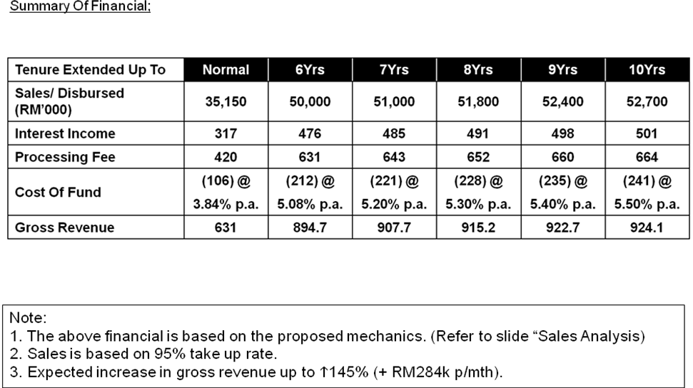

System Enhancement
- The extension of tenure enhancement will involve LOS and AS400 which the enhancement will be catered and develop by internal ACSM ITG team.
- Both extension of tenure and cash back feature initiative will be launch upon the completeness of each system enhancement initiative.

Marketing/ Sales Strategy
- Print material
- Below-the-line (BTL) materials to be distributed at all CSU:
- Product Brochures/Leaflets
- Local area marketing

Legal Vetting/ Documentation
- All necessary documentation pertaining to the product will be vetted by legal & compliance department prior to product launch.

Action Plan
Below are the action plans and the department involved for the above initiative;

 | BU | RMD | L&C | ITG | FIN | CAD | CPM | A&P | CSU/ Branch/ CCD | EC/ MD
New Business/ Product Assessment (NBPD Form) |  |  |  |  |  |  | 
Product new clause terms & condition and PDS |  |  | 
Present concept paper to Executive Committee during the EC meeting |  |  |  |  |  |  |  |  |  | 
Workflow approval |  |  |  |  |  |  |  |  |  | 
HQ Approval – Concept Paper | 
BOD Approval – Concept Paper | 
Present Comprehensive Proposal Paper to EC |  |  |  |  |  |  |  |  |  | 
HQ Approval – Comprehensive Paper | 
BOD Approval – Comprehensive Paper | 
System Development |  |  |  |  |  |  | 
User Acceptance Test (UAT) |  |  |  |  |  |  | 
BNM Approval | 
Marketing Collateral |  |  |  |  |  |  |  | 
Training & communication to sales ground |  |  |  |  |  |  |  |  | 
Product launch & Live |  |  |  |  |  |  |  |  | 

Implementation Timeline
Below are the summary of the tentative timelines;

# | Task | Tentative Deliverable Date
1. | New Business/ Product Assessment (NBPD Form) | 02 Sept 2014
2. | Present to Executive Committee during the EC meeting | 11 Sept 2014
3. | Obtaining approval from Japan HQ on concept paper | 15 Sept 2014
4. | Obtaining BOD approval on concept paper | 18 Sept 2014
9. | System development | 12 Sept 2014
10. | User Acceptance Test (UAT) ends | 19 Sept 2014
11. | BNM notification | 19 Sept 2014
12. | Training & communication to sales ground, CCD, CAD | 19 Sept 2014
13. | Product Enhancement Launch | 22 Sept 2014

Bank Negara Requirement
In accordance to Bank Negara Malaysia’s (BNM) new Guidelines on Introduction of New Products, AEON iCASH product feature enhancement proposition is not listed in the negative list.Upon approval of these initiatives by ACSM management, a notification to Bank Negara will be prior to launch as launch and file.

Summary Of Approval Sought
We would seek management approval with the proposed risk analysis with no material risk to the existing product’s risk portfolio to extend PF tenure up to 96 months.

Appendix I:

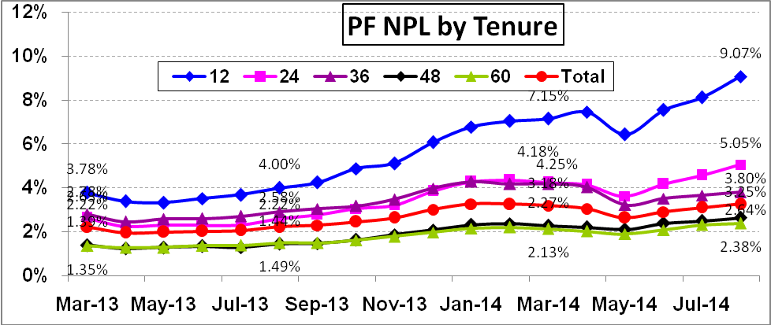

Table 1.0: 16 months of PF NPL Analysis VS Loan Tenure
Appendix I:
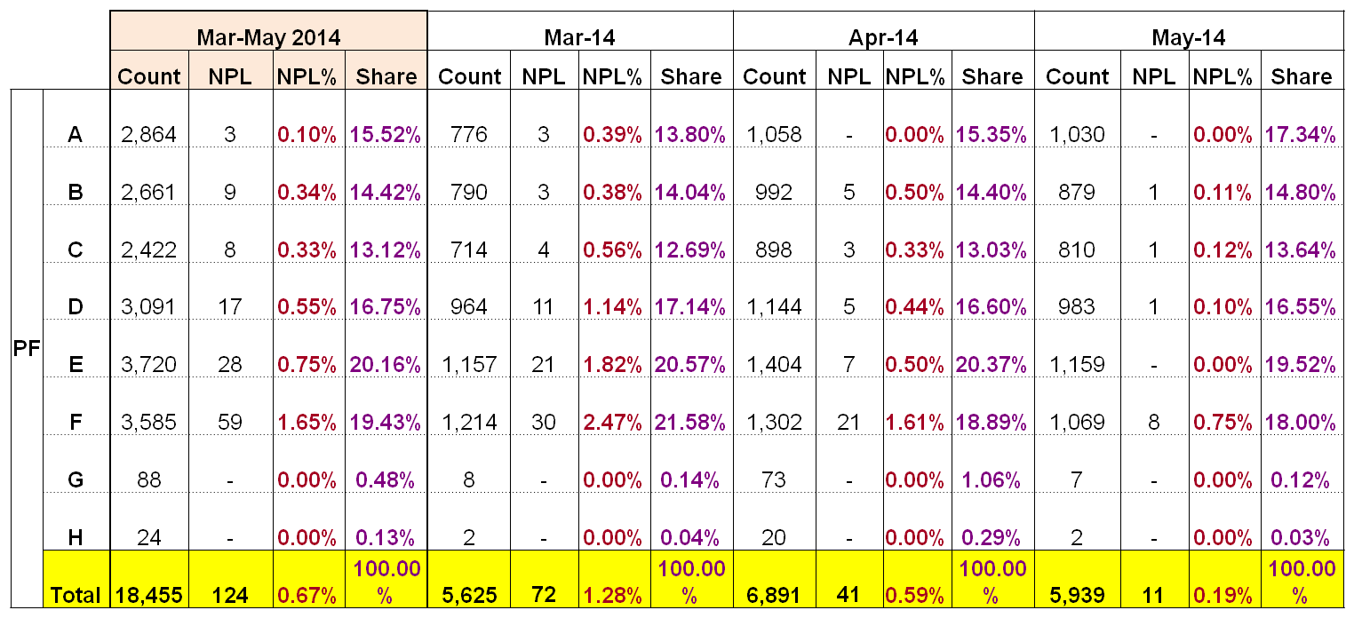

Table 1.1: 3 months of PF NPL Analysis VS Score Rank

Appendix II:
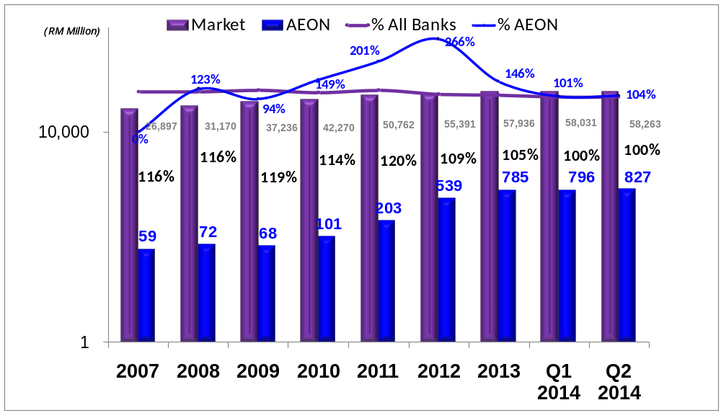

Table 2: ACS PF Receivable growth VS Market receivable growth as at Q2 FYE 2014/ 2015.
Appendix III:

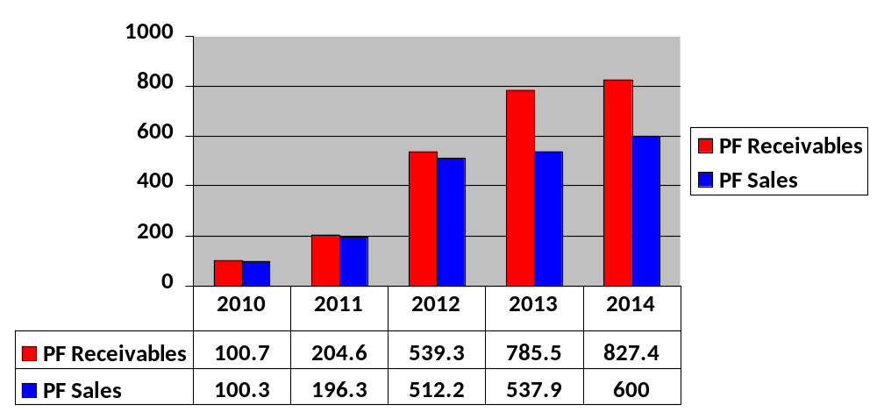

Table 3: ACS PF Receivable growth VS PF Sales FYE 2010 – 2014. Kindly refer to table 4 for expected new monthly sales with the extension of tenure.
Appendix III:

 | Tenure Extended Up To | 6Yrs | 7Yrs | 8Yrs | 9Yrs | 10Yrs
 | BAU Avg. Approved Sales (RM’000) | 35,150 | 35,150 | 35,150 | 35,150 | 35,150
(+) Additional New Approved sales | Part I: Declined Case Being Approved
(+) Additional New Approved sales | Option (1) Score Rank A-B | +10% | +10% | +10% | +11% | +11%
(+) Additional New Approved sales | Option (2) Score Rank A-C | +14% | +15% | +15% | +16% | +16%
(+) Additional New Approved sales | Option (3) Score Rank A-D | +21% | +22% | +22% | +23% | +23%
(+) Additional New Approved sales | Option (4) Score Rank A-E | +28% | +30% | +31% | +32% | +32%
(+) Additional New Approved sales | Option (5) Score Rank A-F | +36% | +38% | +40% | +41% | +41%
(+) Additional New Approved sales | Option (6) Score Rank A-G | +52% | +55% | +57% | +59% | +60%
(+) Additional New Approved sales | Part II: Increase Ticket Size For Existing Approved Case
(+) Additional New Approved sales | Option (7) Score Rank A-B | +13% | +14% | +15% | +16% | +16%
(+) Additional New Approved sales | Option (8) Score Rank A-C | +19% | +20% | +22% | +23% | +23%
(+) Additional New Approved sales | Option (9) Score Rank A-D | +27% | +28% | +30% | +31% | +32%
(+) Additional New Approved sales | Option (10) Score Rank A-E | +36% | +38% | +40% | +41% | +42%
(+) Additional New Approved sales | Option (11) Score Rank A-F | +45% | +48% | +49% | +51% | +52%
(+) Additional New Approved sales | Option (12) Score Rank A-G | +45% | +48% | +49% | +51% | +52%
(+) Additional New Approved sales | Option (13) Score Rank A-H | +45% | +48% | +49% | +51% | +52%

Table 4: Expected new monthly sales with the extension of tenure.

